SSS2.5 HTML Development
The initial NovaTech Computer Solutions website was developed using HTML5. Semantic HTML elements were used to provide a logical structure for the website and to organise the content clearly. The website consists of six interconnected pages, with a consistent navigation menu allowing users to move between the different sections of the website.

2.5.1 HTML5 Website Structure
The NovaTech Computer Solutions website was developed using HTML5 and consists of six interconnected web pages. Semantic HTML5 elements such as <header>, <nav>, <main>, <section> and <footer> were used to organise the content logically. The website also uses headings, paragraphs, lists, hyperlinks, images and form elements to present the required content. Descriptive comments were included within the HTML code to explain the purpose of the main sections.

2.5.2 Website Pages and Browser Testing
Each HTML page was tested in a web browser to confirm that the content displayed correctly and that the navigation links functioned between the pages. Images were also checked to ensure that they loaded correctly. The enquiry form was tested to confirm that the HTML required-field validation functioned correctly.

Figure 3: NovaTech Computer Solutions Home page
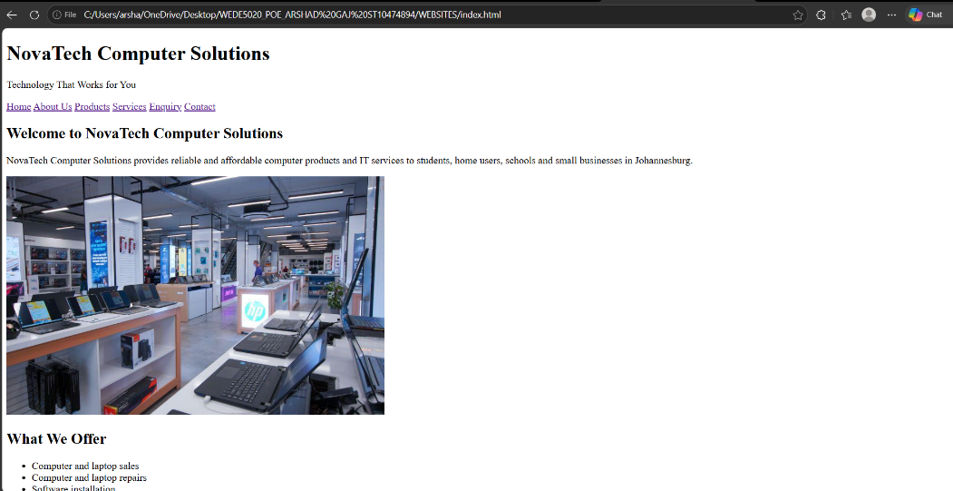

Figure 4: NovaTech Computer Solutions About Us page
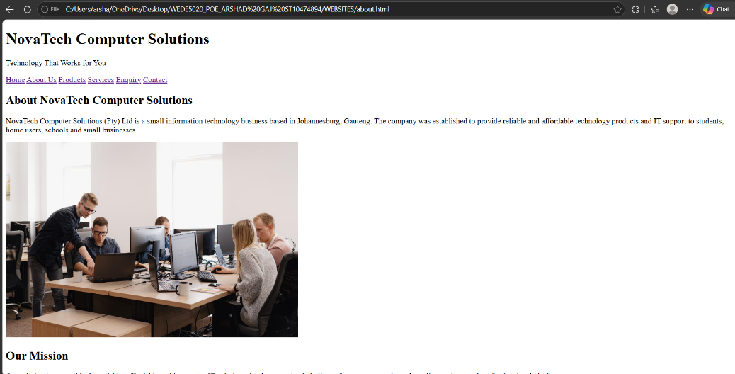

Figure 5: NovaTech Computer Solutions Products page
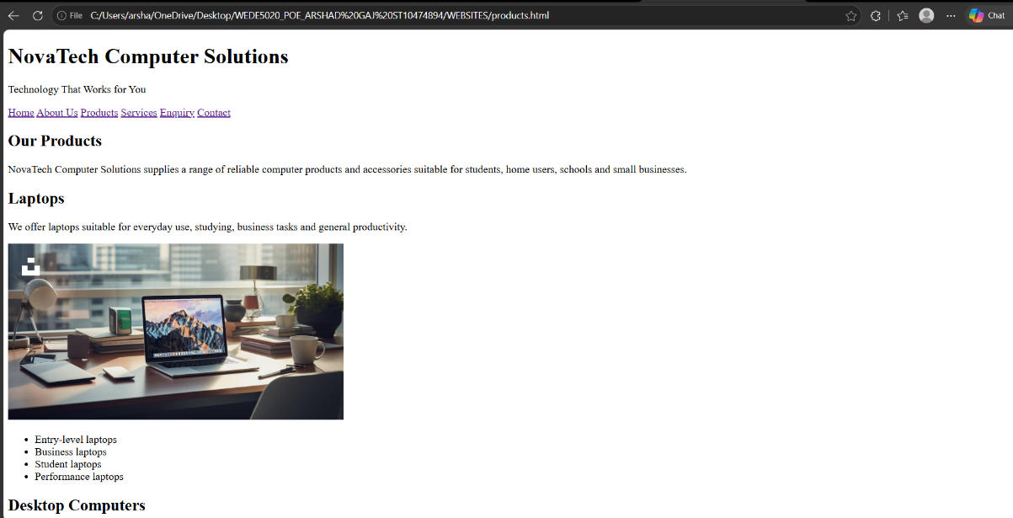
Figure 6: NovaTech Computer Solutions Services page
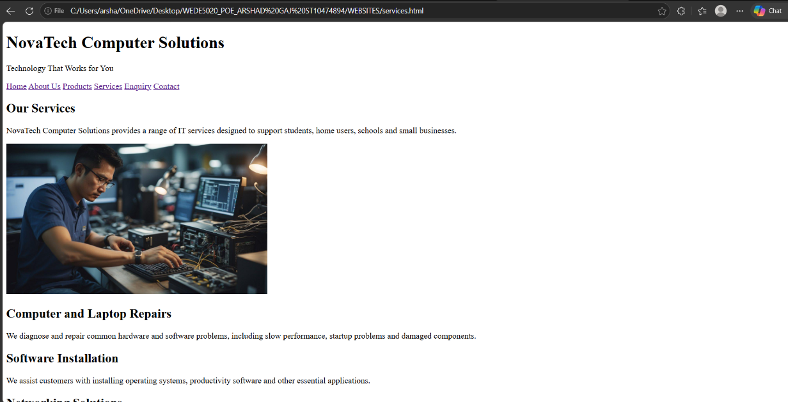
Figure 7: NovaTech Computer Solutions Enquiry page
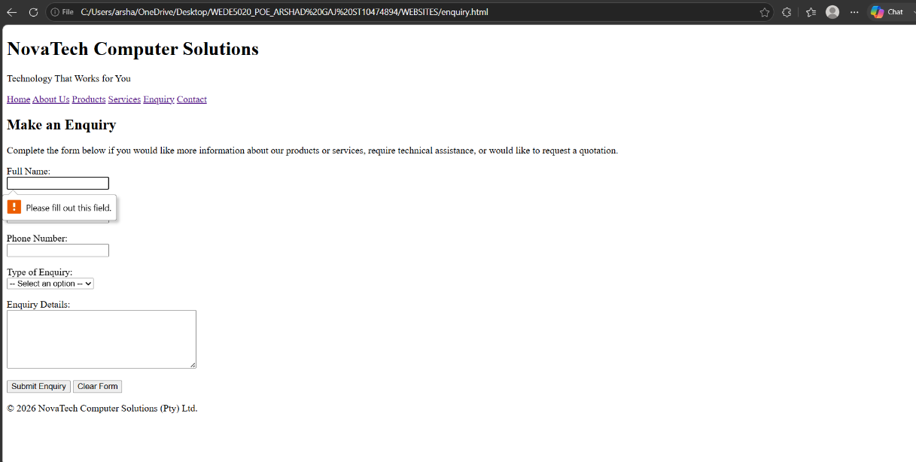

Figure 8: NovaTech Computer Solutions Contact page
